Minnaminni -Aadugramam

Minnaminni is one of the groups in Ranni Aadugramam. It is a microenterprise unit started in 2014. It was a joint venture of Kudumbashree and Panchayat. Kudumbashree provided 25000 rupees for each family including insurance for goat and their eatables. For making shelter the panchayat has provide 4000 rupees.

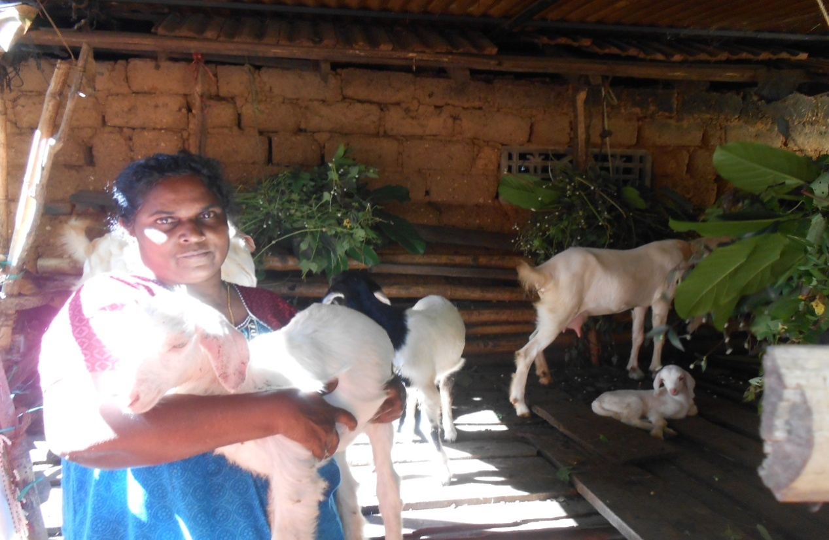
Leelamma Zachariah of Minnaminni Group with her Goats
There are 14 groups having goats. Each group consists of five members. They earn income from milk and dung. The goat rearing provides an entertainment as well as income to them.

