Sree Parthasarathy Handicraft Mirror Centre
Sree Parthasarathy Handicraft Mirror Centre work since last 11 years for making Aranmula Mirror. Sudhammal is alone working for it. She acquired the skill traditionally. It contains a lot of efforts, expertise and patience.
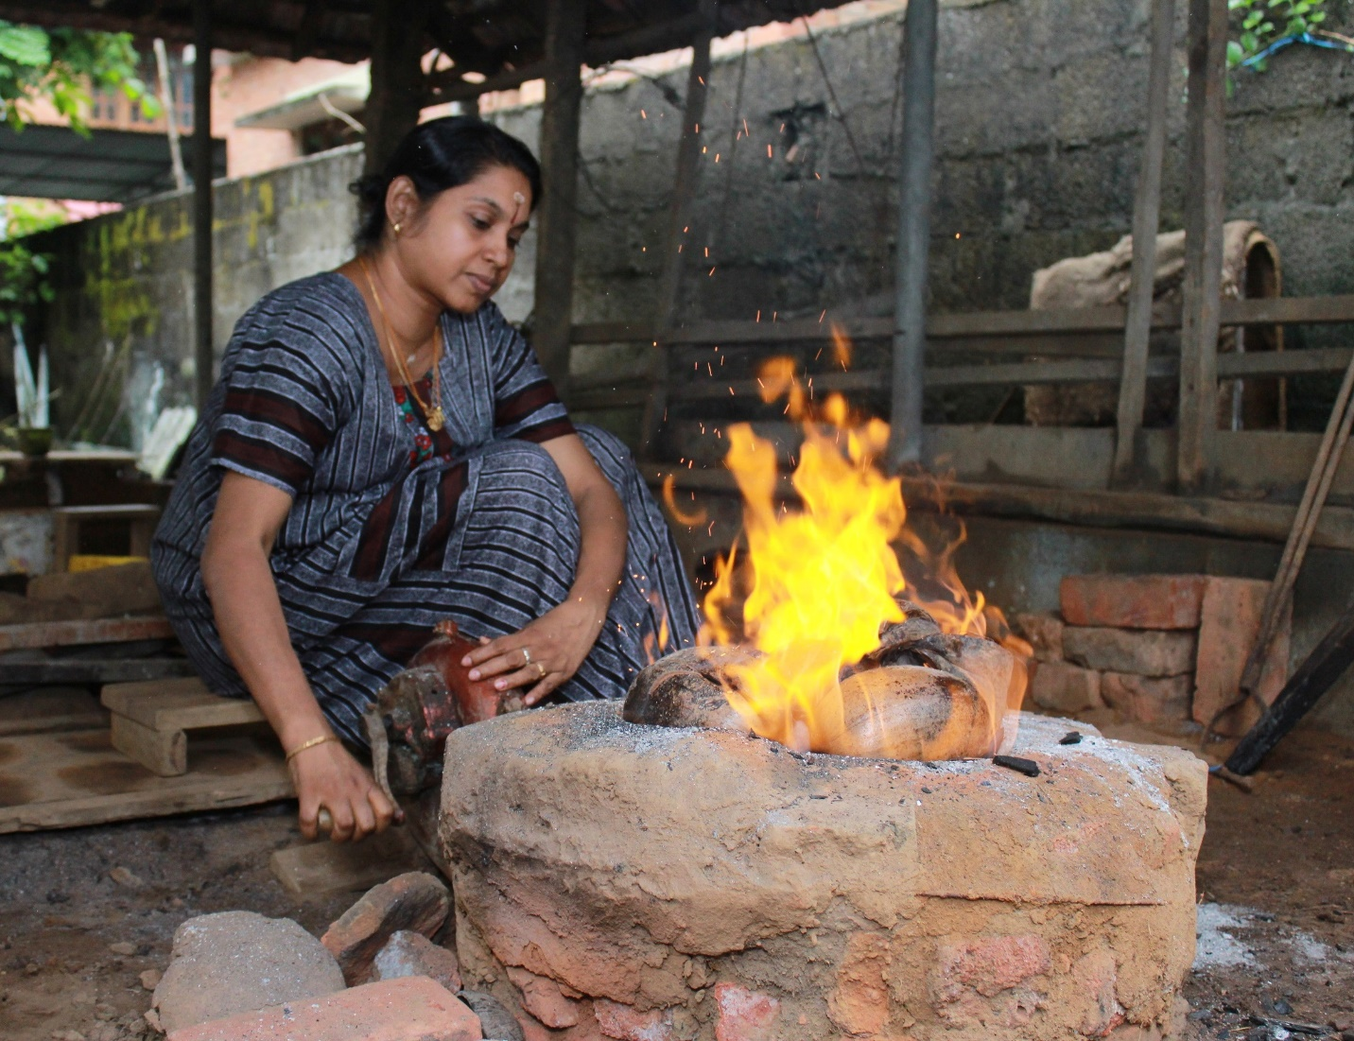
Aranmula mirror is a handmade metal alloy mirror made in Aranmula. It is considered as auspices object kept in household for bringing prosperity, luck and wealth. Sudhammal used to participate in various melas in different parts of Kerala as well as outside Kerala. She used to participate in exhibitions conducted by Kudumbashree, IITF, Government handicraft exhibitions and so on. It costs from 1200 rupees to 1 lakh.

