Bharat Flower Mill Curry Powder
Bharat flower mill curry powder micro enterprise unit is run alone by Valsla.It runs successfully from 2015. Her product ranges from curry powder to rice powder. The products are marketed as door to door delivery system and in government offices.
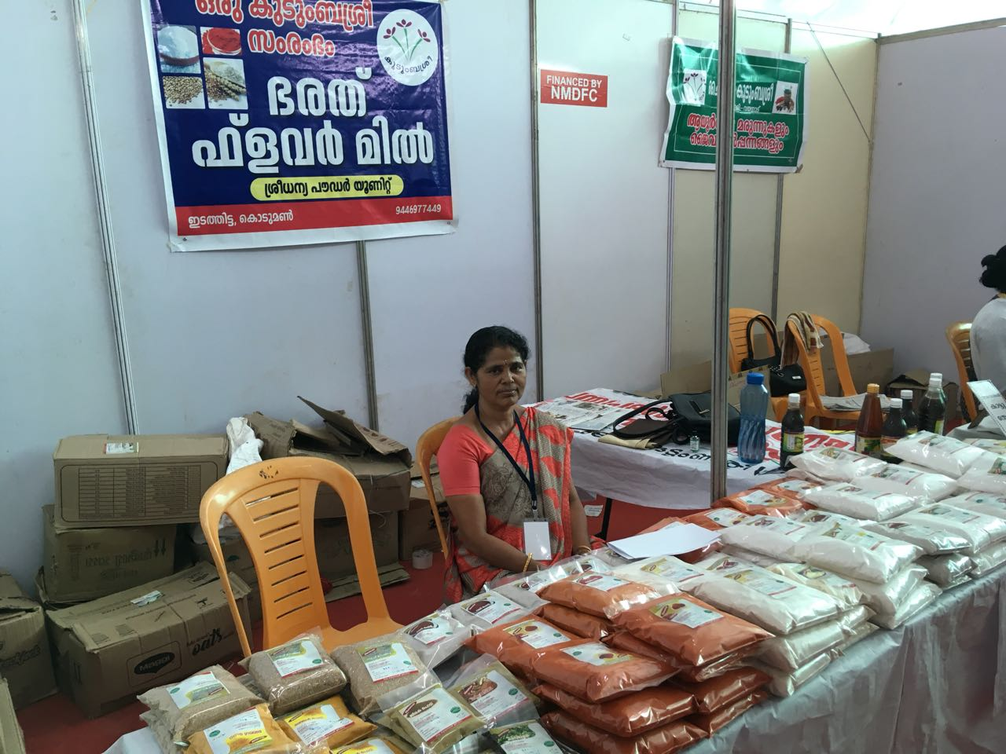
Valsala is a member of Navajyothi Neighborhood group. The products include Coconut oil, Red chilly, Kashmiri chilly, Ragi powder, Idiyappam powder, Chemba puttupodi, vellaputtupodi, coriander owder, turmeric powder, garam masala, pepper powder etc. She earns 1000 to 1500 rupees in a day.

