Vidhya Book Binding
Vidhya book binding is a micro enterprise unit in Nedumparam. They are vof 8 members. They compete with other branded companies in the notebook industry. They were so busy in the month of April and May.
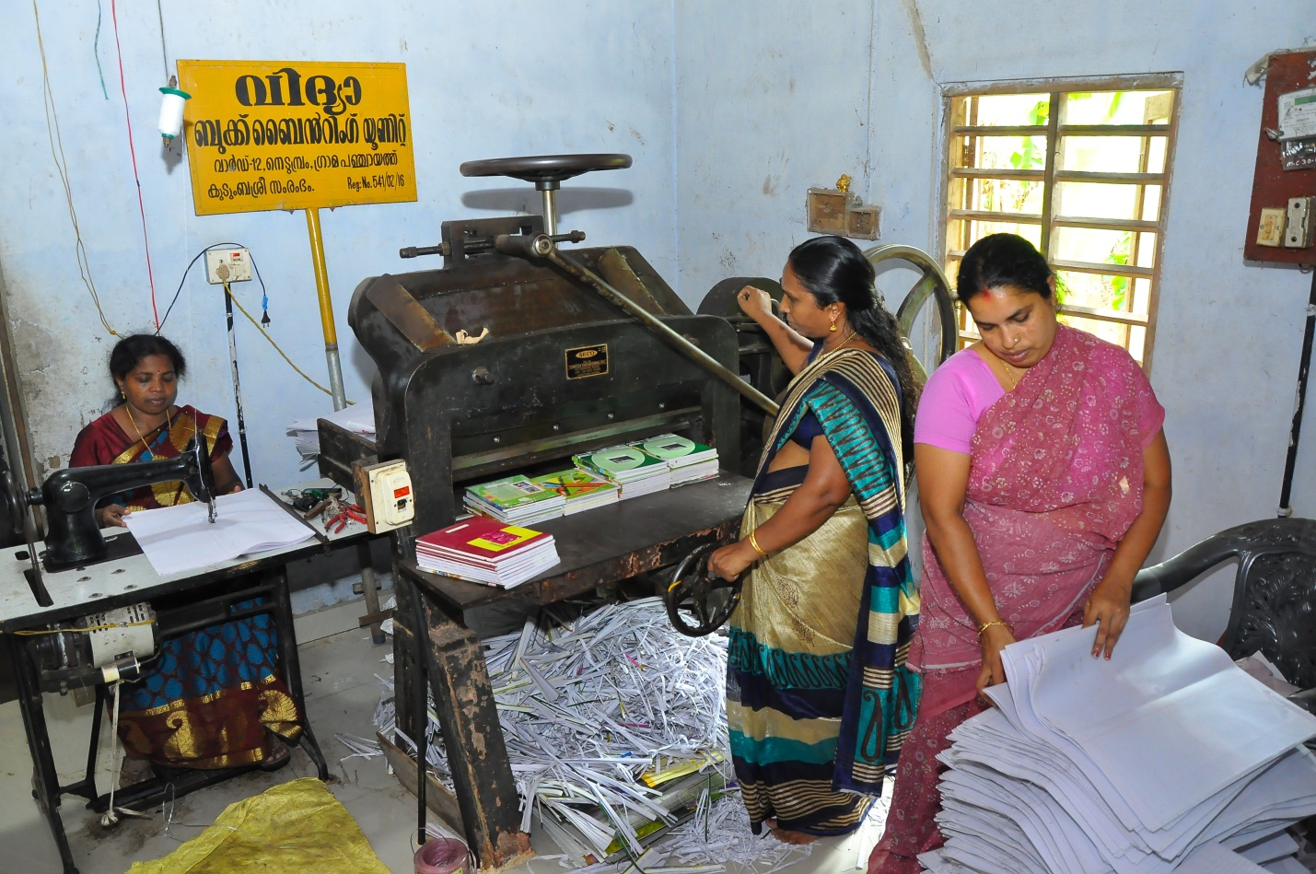
Vidhya Book binding has the experience of 14years in this field. Many organisations approach them for book s to supply in schools. They got subsidy of 1 Lakh as well as 35000 rupees as revolving fund. They start their work on January and continue till May. They earn the profit of 2 lakhs in a year.

